News
Edition No.9

Edinburgh Relay Marathon
11th June 2006



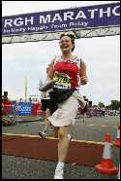
Mattie crossing the line for the team.

Huge congratulations must go to Mattie, Joanne, Helen, Drew & Ian for completing the Edinburgh Relay Marathon in a time of 4hrs 47mins 33 secs.

An admirable time considering the heat on the day and the fact that for most of the team this was there first (and last) experience of distance running. In the process £974 was raised for The Muir Maxwell Trust, a charity for children suffering from epilepsy. Thanks must go to you, our customers, for your support.

New Products

Ultimate Paint Remover
The strongest paint, varnish and lacquer remover on the market. In our opinion Ultimate is twice as good at removing Paint as the brand leader Nitromors. It is available in 5L at a cost of £28.00 +VAT.

Please contact us for further information.

2 Pack Floor Coating – Proflor Duo

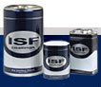

We can now supply a two pack AC lacquer for floors called Proflor Duo. It is available in 5%, 10%, 25%, 35%, 50 % & 90% sheen levels at £40.50/5L unit.

Konig Course

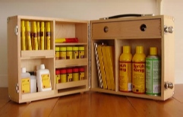

The next Konig Course will take place on Tuesday 12th September 2006 at our premises, places are still available, please contact us if you wish to attend.

►SALE◄

S&R Danish Oil
£22.35 £17.00/5L
(Until 30th September 2006)

S&R Database

In order to improve our efficiency, we would greatly appreciate it if you could email us so that we can add your electronic details to our database. This will ensure there is no chance of customers missing out on news, or special offers. Please email us at info@smithandrodger.co.uk

SAIT Abrasives
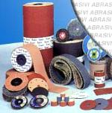

An increasing number of customers are now sourcing their abrasive requirements from us. This includes rolls, discs, sponges, strips and belts. Please contact Joanne when you are next in the market for abrasives and she will provide you with a highly competitive quote and quality abrasives.

Saturday Opening

As from Saturday 2nd September we will be open for business each Saturday from 9am – 12 noon.
We hope this will allow many potential customers to visit our premises out of normal office hours.

(This will take place on a trial basis for 6 months with a view to making it permanent)

